**Newtown’s Cultural Infrastructure – Illustrated interactive spatial map**

**Summary**

The Legacy Centre of Excellence CIC is looking to commission the development of an illustrated and interactive map of creative and cultural assets of the Newtown ward area, which is interactive and shows key cultural and artistic landmarks and assets - The map should be made available to be included in the Newtown Cultural Strategy Document as well as in a form that can be embedded in a website.

What we are looking for

An artist, creative, or digital creative/group with an interest in Newtown ward, Birmingham to create an illustrated interactive visual spatial map.

Budget – 1 commission of up to £3k

Deadline for EOIs – 9th Feb 2025

Decision communicated W/C 9th Feb

Map to be created and provided to Legacy Centre of Excellence by or before March 20th 2025

Payment will be 50% upfront, 25% provision of initial draft map and 25% on provision of the final map (approved by client)

Main contact for any queries [angela.jeffery@legacycoe.co.uk](mailto:angela.jeffery@legacycoe.co.uk)

Monitoring and evaluation requirements: provide evidence of any community participation and participate in evaluation as required by Birmingham City Council or Legacy Centre of Excellence.

**1, Background**

The Legacy Centre of Excellence C.I.C. have been commissioned by Birmingham City Council as part of the Commonwealth Games legacy to bring together creatives, artists, residents and other stakeholders in Newtown to develop cultural placemaking plans and develop a strategy that dovetails with Birmingham City Council’s Public Art Strategy and Future City Framework 2045. See the [Draft Newtown Cultural Strategy](https://www.legacycoe.co.uk/_files/ugd/28633a_b53328aa906a48158ada25d95ecfa6b7.pdf) for details of the area, mapping conducted to date and ideas for the future. WMCA have already created an interactive map that shows some of the cultural locations [WMCA Cultural Explorer](https://experience.arcgis.com/experience/f519267d1a1247329a8b3f0e8bd08d37?id=716ebc7ff00c4361943b9dedf4aa3006), we are looking to take this further specifically for Newtown to include pictures to bring the map to life so that it is easy to see the array of assets available (red line shows the Newtown ward border).

Below Fig shows a screen shot of the existing WMCA Cultural Explorer map of Newtown (with border drawn around it for reference).

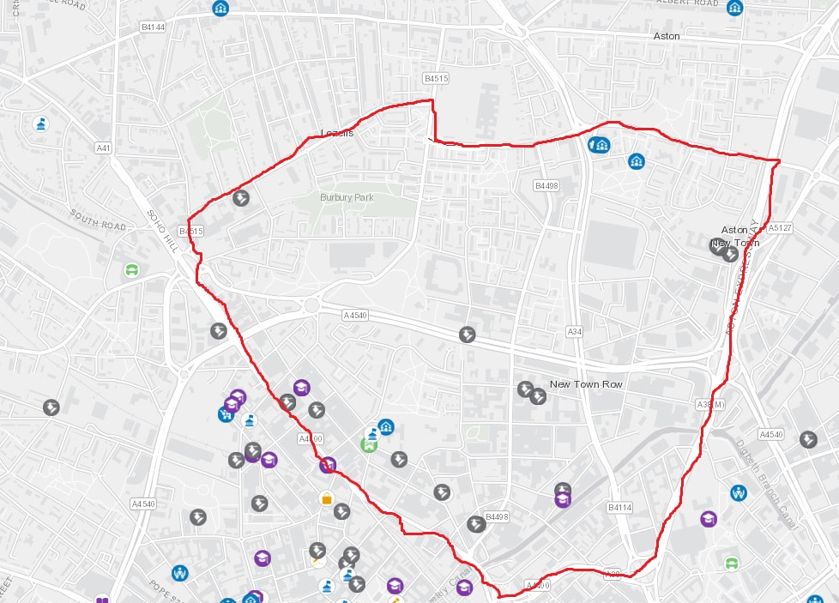

**2 What we are looking for**

An artist, creative, digital creative or group with an interest in Newtown ward, Birmingham to create an illustrated interactive spatial map. The map should be made available digital form to include in the Newtown Cultural Strategy and to be embedded into a webpage.

What good looks like – examples from other locations

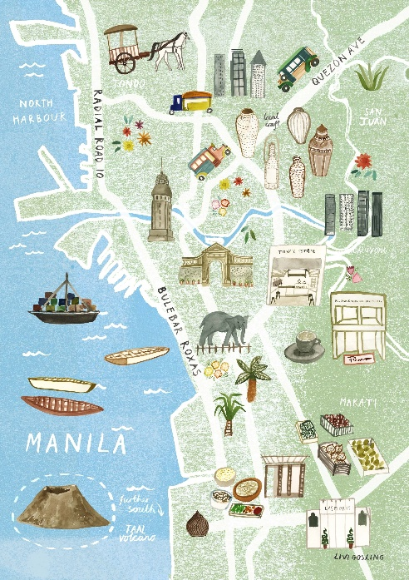

**Expression of Interest**

**Please provide information summarising your project:**

Name

Contact details

Title of project

**1, A short profile of the artist or organisation (400 words max).**

**2, An outline proposal of what you plan to create, who you will involve and what materials you will use.**

**3, Impact: explain what impact your project will have on Newtown and its people.**

**4, Examples of previous work.**

**5, Provisional budget:** Budget breakdown – tell us what you will spend the money on and the total cost including VAT.

**6, Signature** – to confirm that if awarded, the illustrated map could be created, completed and made available before 20th March 2025.

**Submitting you EOI - please send your Expression of interest to** [**Angela.jeffery@legacycoe.co.uk**](mailto:Angela.jeffery@legacycoe.co.uk) **by midnight on the 9th Feb 2025**

**Selection process**

Criteria

Must involve producing an illustrated map of cultural assets of Newtown

Ideally involve Newtown based or affiliated artists, but this is not an absolute requirement.

Timeline

The deadline for bids is 9th Feb 2025

EOIs will be assessed by a selection panel who will meet on W/C 10th Feb 2025

Decisions will be made and successful applicant will be informed by W/C Feb 10th 2025

Map to be created and installed by March 20th 2025

Max budget is £3k including VAT if applicable.

The selection panel’s decision is final.